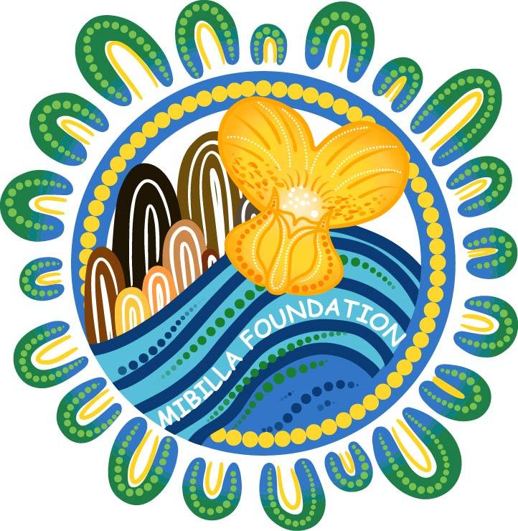
Mibilla Foundation
Grant
Program

Grant Acquittal Submission Guide
Thank you for being part of the Mibilla Foundation community. This acquittal helps us understand how the funding was used, what impact it created, and how we can continue improving our programs and support.
You may complete this acquittal in one of the following ways:
OPTION 1 Create a short video responding to the questions in the ‘Project Outcomes’ and ‘Feedback’ section. Videos can be submitted via:
Email: connect@mibilla.org
WhatsApp: 0400 076 048
Supporting financial documents can be sent separately via email.
OPTION 2 Written Acquittal
Complete the form below and return it with supporting documents to: connect@mibilla.org

Applicant Details

Organisation Name
Contact Person
Contact Information
Project Name
Grant Amount

Financial Acquittal
Please provide a brief summary of how the grant funds were used.
All acquittal amounts must be reported GST inclusive and match the invoices provided.
Item Description | Amount | Receipt Attached
 |  | - ☐
 |  | - ☐
 |  | - ☐
 |  | - ☐
 |  | - ☐
Total Grant Expenditure (Total must equal the allocated grant amount) | $

Project Outcomes

- Please provide approximate numbers where possible.

Outcome | Number
Number of participants involved
Number of community members reached
Number of events/workshops/activities delivered
Number of volunteers/staff involved
Number of resources/equipment purchased

- What did the funding help you achieve?

- What difference did this funding make for your organisation or community?

- Were there any unexpected outcomes, successes, or challenges?

- Was the funding used as originally planned?
☐ Yes
☐ Mostly
☐ No
If there were changes, please briefly explain:

- Which of the following changes best reflect your experience? (tick any that apply)
- ☐ Increased confidence or skills
- ☐ Improved financial stability or income
- ☐ Increased participation or engagement
- ☐ New or strengthened employment opportunities
- ☐ Stronger partnerships or relationships
- ☐ Increased self-determination or independence
- ☐ Reduced stress or financial pressure
- ☐ Stronger community connections
- ☐ Leadership skills strengthened
- ☐ Improved access to services or opportunities
☐ Other:

Feedback
As part of the acquittal process, your feedback will help us evaluate and improve the Mibilla Foundation Funding Program.
How would you rate your experience with the application and acquittal process?
- ☐ Excellent
- ☐ Good
☐ Fair
- ☐ Poor

Did you feel the application and reporting requirements were clear?
- ☐ Yes
- ☐ Mostly
☐ No

Is there anything we could improve or make easier?

Is there anything else you would like to share with us?

Media Permission
☐ The organisation gives permission for Mibilla Foundation to use project information, quotes, and photographs provided as part of this acquittal for reporting, promotional, website, social media, marketing, and funding purposes.
☐ The organisation confirms appropriate consent has been obtained from individuals pictured in photographs provided.

Declaration
I confirm that:
- the grant funds were used for the approved purpose
- the information provided in this acquittal is true and correct
- supporting documentation is available and attached where required
Signature
Name
Date

Thank you for your feedback.
We appreciate the opportunity to support your work and learn from your experience.

